Dear Colleagues,  25 Years Guiding World Culture and Heritage:  WFTGA 1985-2010  As we enter our 25th anniversary year, the Executive Board of WFTGA sends greetings and best wishes to all our members and friends around the world.  We now have members in 52 countries worldwide – a huge achievement from the early beginnings with a few dedicated people who had a vision for an international fellowship for tourist guides.  2009 has not been an easy year for anyone in the tourism industry but I am sure working together as a professional body of guides gives us all greater strength and power.  Even more important is the friendship we gain from one another and the wonderful hospitality which we receive when we get together as we did in Bali.  We look forward to a year of celebration culminating in our Convention in 2011 in Tallinn, Estonia.  From a snowy Scotland, I wish you and your friends and families well for 2010.  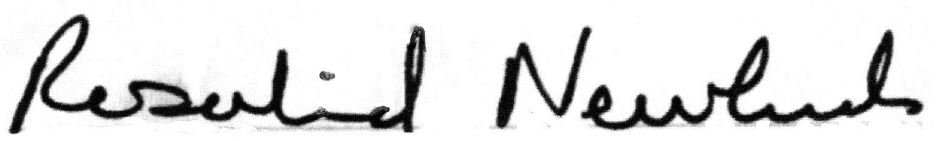  WFTGA President | 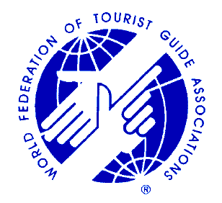  World Federation of Tourist Guides Associations  Rosalind Newlands  WFTGA President  22 Winton Terrace  Edinburgh EH10 7AP  Scotland  UK  Tel: +44 (0)131 477 2204  Mobile +44 (0) 7885329538  info@wftga.org  14th WFTGA Convention  Tallin, Estonia: Culture a Unifying Guide  30th January – 4th February 2011  Follow Us and Discover Our Special Heritage  We stand for standards and quality in tourist guides  We are the professionals!  We promote training and qualifications for tourist guides  We are the professionals!  We support codes of practice and quality charters for tourist guides  We are the professionals!  WFTGA Sponsored and Supported by  The Cyprus Tourist Guides Association: The Cyprus Tourism Organisation  The University of Cyprus; Androus Foundation; Scottish Tourist Guides Association  University of Edinburgh; Vienna Chamber of Commerce  Registered Office:  Vienna Austria  www.wftga.org

